|  |  |
| --- | --- |
| FARIWeb App Functional Specs |  |

DOCUMENT History

|  |  |  |  |
| --- | --- | --- | --- |
| Date | Version | Description | Author |
| 9/30/2022 | v1.4.2022 | Initial | Rashon Williams |
|  |  |  |  |

CONTENTS

|  |  |  |  |
| --- | --- | --- | --- |
| Overview |  |  | Page 3 |
| Registration |  |  | Page 4 |
| Login |  |  | Page 5 |
| Dashboad |  |  | Page 6 |
| Explorer |  |  | Page 8 |
| Theater |  |  | Page 11 |
| Marketplace |  |  | Page 13 |
| Vendor-Registration |  |  | Page 15 |
| Upload |  |  | Page 16 |
| Product Details |  |  | Page 17 |
| Chat |  |  | Page 18 |
| Profile |  |  | Page 20 |
| Channel |  |  | Page 22 |

Overview

Fari is a subscription based, video sharing platform, that allows independent content creators and vloggers to directly monetize their content and brand.

The platform allows creators to list works such as independent movies, short films, or any webseries episodes for a price of their choice while keeping 100% profit of their work.

Key Modules

* Explorer
* Marketplace
* Chat
* Profile

Database Scheme: (PostgresSQL)

https://lucid.app/lucidchart/8a928feb-585f-440f-91ab-ecbf70c6d24f/edit?viewport_loc=-78%2C4442%2C3488%2C1548%2C0_0&invitationId=inv_f53672ad-5b4b-41cc-91a0-4c837c4e0041#

Registration

Fari user registration form, requires a unique username and email, with a confirmed password check.

Database Tables:

Users, user_channel, vendors are populate after success registration has occurred with the username, channelname, and vendorname columns populating with the entered username and users.id populates as the id for the userid column (user_channel table) and vendorid column (vendors table).

Users’ table stores the username, email and password.

API Call (POST):

api/users/register

Welcome email (POST) – api/mailer/welcome/:email

FUNCTIONAL RISK:

User is assinged a JSON Web Token with no expiration period.

Login

Fari user login form, requires user place in a valid username and password.

Forgot Password, is also available via the login form.

Database Tables:

Users table is checked for valid username and password confirmation.

API Call (GET):

api/users/login

FUNCTIONAL RISK:

After successful login, user’s webtoke, email, username, userid, profile photo, and stripe account ID, are stored in the devices local storage.

Dashboard

After successfully logging in, users will be directed to the Dashboard page, where they decide where to navigate to next, via a toggoling menu button. The Dashboard initially displays the a user hello, with their username displayed, profile avatar, and a slider containing information on what they can do on the application.

API Call (GET):

api/users/myprofile

Explorer

The explorer is the video hub for all uploaded video content.

Content can be sorted, by free or paid content and by category.

Menu:

* The ‘Discover’ menu option allows for randomized content that is listed as free content.
* The ‘Pay to View’ menu option list content that users have opted to charge for viewing
* The ‘Subscriptions’ option displays both free and paid content from users that the user had subscribed to.
* ‘Favorites’, and ‘Watchlist’ menu options are user curated list based on the user’s interest.
* The ‘Watch History’ option contains a list of recently viewed free content. The list keeps up to 15 days of history.

Category:

* The ‘Movies & Films’ section list any video content listed as free and categorized or tagged as a movie, film, or short film.
* The ‘Shows & Web series’ section list any video content listed as free and categorized and tagged as a Web series, show, series, etc.
* The ‘Animations’ section is a list of free animated content
* The ‘Vlogs’ section is a list of free video vlogs from creators

Explorer (cont.)

The right pane, consist of 4 different windows, depending on the user’s active menu or category selection:

Discover and Pay to View show, on the right pane, a table of popular user channels, based on highest subscription count and a list of popular videos based on like count.

Subscriptions, Favorites, Watchlist, and Watch History display randomized list of the user’s subscribers and a list of their subscribers if they are live.

API Calls:

api/content/discover (GET) – Discover Tab

api/content/paytoview (GET) – Pay to View tab

api/content/mysubscription-videos/ :userid (GET) – Subscriptions

api/content/myfavorites/:userid (GET) – Favorites

api/content/mywatchlist/:userid (GET)- Watchlist

api/content/mywatchhistory/:userid (GET) – Watch History

api/content/movies (GET) – Movies & Shows

api/content/shows (GET) – Shows & Webseries

api/content/animations (GET) - Animations

api/content/vlogs (GET) – Vlogs

Right Pane

api/content/popular-channels – (GET) – Popular Channels

api/content/popular-uploads – (GET) – Popular Uploads

api/content/ mysubscriptions /:userid (GET) – Subscriptions

api/content/mysubscriptions/livechannels/:userid (GET) – Live

New Video Sale Email (POST) – api/mailer/newsale/movierental/:email

EXPLORER (cont.)

Interactive API Calls:

Video Search (GET) – api/content/video-search/:query

User Search (GET) – api/content/channel-search/:query

Play (GET) – api/content/getvideo/:videoid

Navigate to channel (GET) – api/content/channel/:channelid

Add to Watch List (POST) - api/content /add/watchlist-video

Delete Watchlist (DELETE) - api/content /delete/watchlist-video/:userid/:videoid

Add to Favorites (POST) – api/content /add/favorite-video

Delete Favorite (DELETE) – api/content /delete/favorite-video/:userid/:videoid

Purchase Video(POST) – api/content/stripe-checkout/rental

Theater

API Calls:

Play Video (GET) – api/content/play/:videoid

Discover/Recommended Videos (GET) – api/content/discover

Watchlist (GET) – api/content/mywatchlist

Favorites (GET) – api/content/myfavorites

Comments (GET) – api/content/comments/:videoid

Video View Count (PATCH) – api/content/update-viewcount/:videoid

Get Like Status (GET) – api/content/mylikes/:videoid/:userid

Get Dislike Status (GET) – api/content/mydislikes/:videoid/:userid

Add to History (POST) – api/content/add/watchhistory

Interactive Actions

Like Video (POST) – api/content/like-video/:videoid

Dislike Video (POST) – api/content/dislike-video/:videoid

Add to Watch List (POST) – api/content/add/watchlist-video

Add to Favorites (POST) – api/content /add/favorite-video

Flag Video (POST) – api/content/flag-video/ :videoid

Add Comment (POST) – api/content/new-comment

Edit Comment (PATCH) – api/content/edit-comment/:commentid

Delete Comment (DELETE) – api/content/delete-comment/:commentid

Flag Comment (PATCH) – api/content/flag-comment/ :commented

FUNCTIONAL RISK/ISSUE:

Like/Dislike doesn’t always show color change on icon, indicating the user’s like or dislike status.

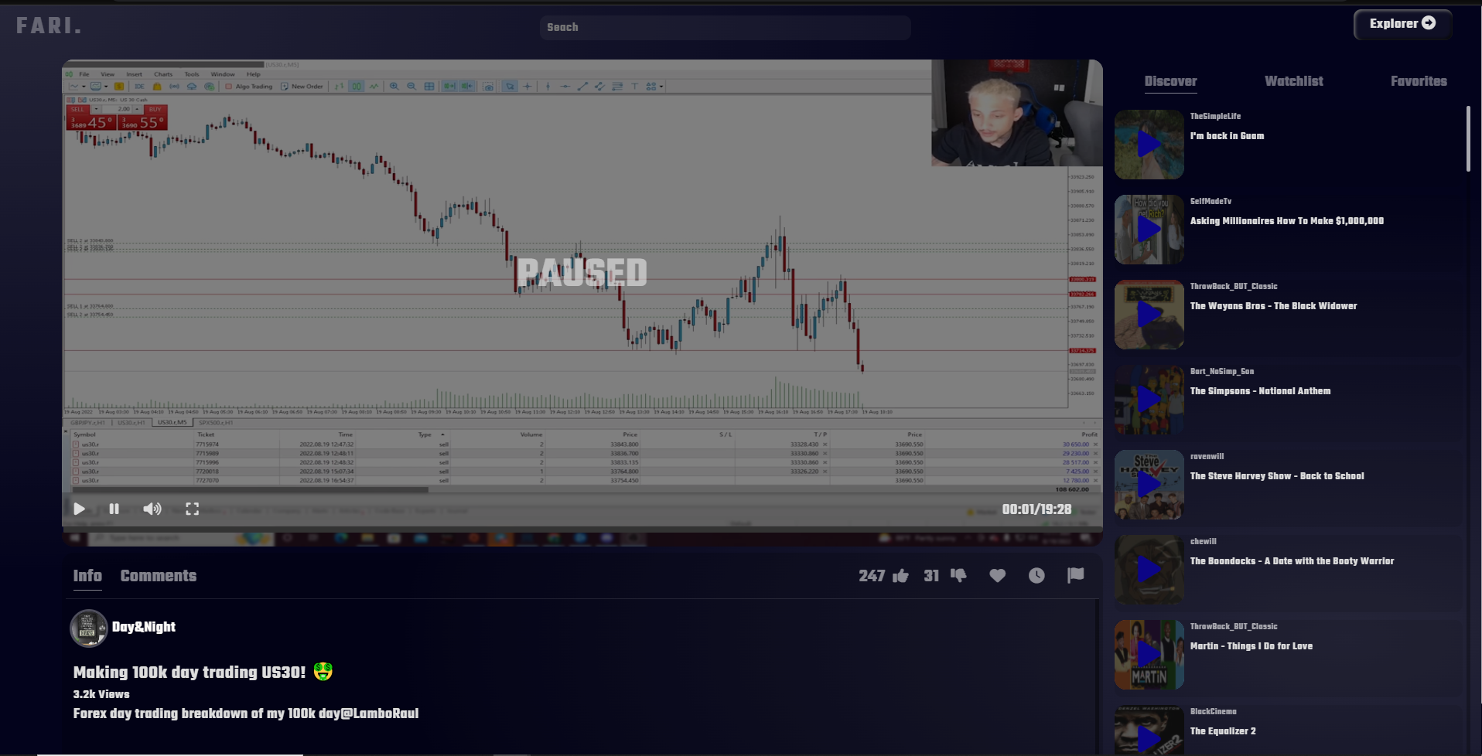

MARKETPLACE

The marketplace is the hub for merchandise to be sold directly to consumers.

Left Pane

Menu:

* The ‘Marketplace’ menu option allows for randomized items listed for sale by vendor.
* The ‘Order History menu option list a history of previously purchased items from user.
* The ‘My Shop’ option displays merchandise that a user has listed as a sale item. (Only available if user is a verified vendor)
* ‘My Customer Orders’ menu option displays a table with a list of orders made by consumers from the users shop. (Only available if user is a verified vendor)

Category:

* The ‘Apparel’ section list any merchandise categorized as Apparel.
* The ‘Accessories’ section list any merchandise categorized as Accessories.
* The ‘Jewelry’ section list any merchandise categorized as Jewelry
* The ‘Electronics’ section list any merchandise categorized as Electronics

Right Pane:

If user is a verified vendor they will see a link that takes them to the upload screen to upload new merchandise.

If user is not a verified vendor they will have the link to Complete Vendor Registration.

Marketplace (cont.)

API Calls

Get Products (GET) – api/marketplace/products

Vendor Verification(GET) – api/marketplace/vendor-verified/:vendorid

Interactive Calls

Get My Orders (Get) – api/marketplace/myorders/:userid

Get My Products(Get)- api/marketplace/myshop-products/:vendorid

Get My Customer Orders (GET) – api/marketplace/myshop-orders/:vendorid

Search Shop(GET) – api/marketplace/search/:query

Apparel – api/marketplace/apparel

Jewelry – api/marketplace/jewelry

Electronics – api/marketplace/electronics

Accessories – api/marketplace/accessories

Vendor Registration

Once both steps are completed the user is directed to the registration complete page.

API Calls:

Stripe Onboarding - api/marketplace/onboarding

Subscribe – api /marketplace/vendor-subscription

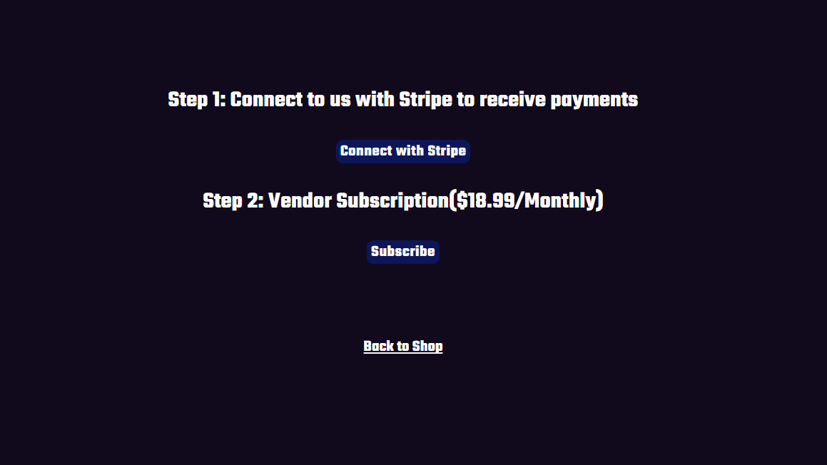

Registration Complete:

API Calls: Setting Flags

Registered Vendor (PATCH) – api/users/vendor-subscription-update/:userid

Registered Vendor (PATCH) – api/users/vendor-registration/:vendorid

Upload New Product

User uploads new products/merchandise from to marketplace.

API Call:

Upload (POST) – api/marketplace/new-product

PRODUCT DETAILS/CHECKOUT

Product page display the selected product details from the marketplace.

Users are able to make a single item purchase, which is linked to the vendors Stripe Account/store.

API Calls (GET) – api/marketplace/product-details/:productid

Checkout Calls:

Create Order (POST) – api/marketplace/new-order

Create Shop Order (POST) – api/marketplace/product-order

Stripe(POST) – api/marketplace/stripe-checkout

New Sale Email (POST) – api/mailer/newsale/marketplace/:email

CHAT

Chat is an avenue for users to connect with other users.

API Calls:

Conversations (GET) – api/chat/myconversations/:userid

Get Conversation Messages(GET) – api/chat/myconversation-messages/:conversationid

Get Users (GET) – api/users/usernames

Interactive Calls:

New Conversation(POST) – api/chat/new-conversation

Check if Existing Conversation (GET) – api/chat/conversation-duplication-check/:receiverid/:senderid

New Message(POST) – api/chat/new-message

Email:

New Message Notification (POST) – api/mailer/new-message/ :email

Profile

The profile module is the registered users resource to upload video content and check on their analytics and manage settings.

API Calls:

Get Profile (GET) – api/users/myprofile

Populate Channel Info(GET) – api/user/channel/:username

Get Channel Post (GET) – api/user/channel-post/:channelid

Get Channel Subscriptions (GET) – api/user/channel-subscriptions/:userid

Verfiy Vendor Sub (GET) – api/user/vendor-verification/:vendorid

Analytics Call:

Total Views (GET) – api/analytics/totalviews/:channelid

*Total Earnings:*

Rental Totals (GET ) – api/analytics/totalrentals/:channelid

Marketplace Total(GET) – api/analytics/marketplacesales/:vendorid

Total Likes(GET) – api/analytics/totallikes/:channelid

Total Dislikes(GET) -api/analytics/totaldislikes/:channelid

Total Comments(GET) – api/analytics/totalcomments/:channelid

Total Subscribers(GET) – api/analytics/totalsubscribers/:channelid

*Total Orders:*

Total Videos Sold (GET) – api/analytics/rentedtotal/:channelid

Total Marketplace Sold (GET) – api/analytics/soldproducts/:vendorid

Videos Grid:

Total Sold by Vendor(GET) – api/analytics/rentedcounts/:channelid

Video Sold Count(GET) – api/analytics/rental-sells/:videoid

Marketplace Grid:

Total sold marketplace Items(GET) – api/analytics/marketsellcounts/:vendorid

Total of Product Sold(GET) – api/analytics/product-sells/:productid

Update Avatar (GET) – api/users/myprofile/update/avatar/:channelname

Update Poster(GET) – api/users/myprofile/update/posters/:channelname

Video Upload(POST) – api/content/upload

Channel

The Channel page, is for users to view other creators content and subscribe to their channel

API Calls:

Channel Info(GET) – api/users/channel/:channelid

Channel Post(GET) – api/users/myprofile/post/:channelid

Check if Subscribed(GET) – api/users/substatus/:userid/:channelid

Interactive Calls:

Check Subscription(GET) – api/users/substatus/:userid/:channelid

Subscribe(GET) -api/users/subscribe/:channelname

Unsubscribe(DELETE) – api/users/unsubscribe/:channelname/:userid

Add to watchlist(POST) – api/content /add/watchlist-video

Purchase Video(POST) – api/content/stripe-checkout/rental

